OLYMPIA HEIGHTS ELEMENTARY

“Home of the Pegasus”

9797 S.W. 40TH STREET
MIAMI, FL 33165

(305) 221-3821

Office Hours: 8:00am – 4:00pm



Website: olympiaheights.net

Twitter: @olympiaheights

Instagram: olympiaheightselementary

Miami-Dade County Public Schools
The School Board of Miami-Dade County, Florida

Ms. Mari Tere Rojas, Chair
Ms. Monica Colucci, Vice Chair
Mr. Robert J. Alonso
Dr. Dorothy Bendross-Mindingall
Ms. Mary Blanco
Mr. Danny Espino
Mr. Joseph S. Geller
Ms. Luisa Santos

Student Advisor
Alejandro Duran

Superintendent of Schools
Mr. Rafael A. Villalobos

Office of school leadership and performance
Dr. Michael A. Lewis
Deputy Superintendent

Vision Statement
Inspired, valued, educated, and empowered students thriving in and beyond the classroom

Mission Statement
To provide relevant learning experiences that foster life-long curiosity and enable ALL students to achieve their full academic, personal, and civic potential.

Values
Excellence - We pursue the highest standards in academic achievement and organizational performance.
Equity - We foster an environment that serves all students and aspires to eliminate the achievement gap.
Student Focus - We focus on meeting our students’ diverse needs and supporting them in fulfilling their potential.
Innovation - We encourage risk-taking, creativity and adaptability to new ideas and methods that will support and elevate student learning.
Accountability - We celebrate our successes, learn from our failures, and embrace challenges as we strive towards continuous improvement.
Joy - We accept individuals for who they are, encourage them to engage with one another authentically, and cultivate welcoming environments that promote fun and excitement.

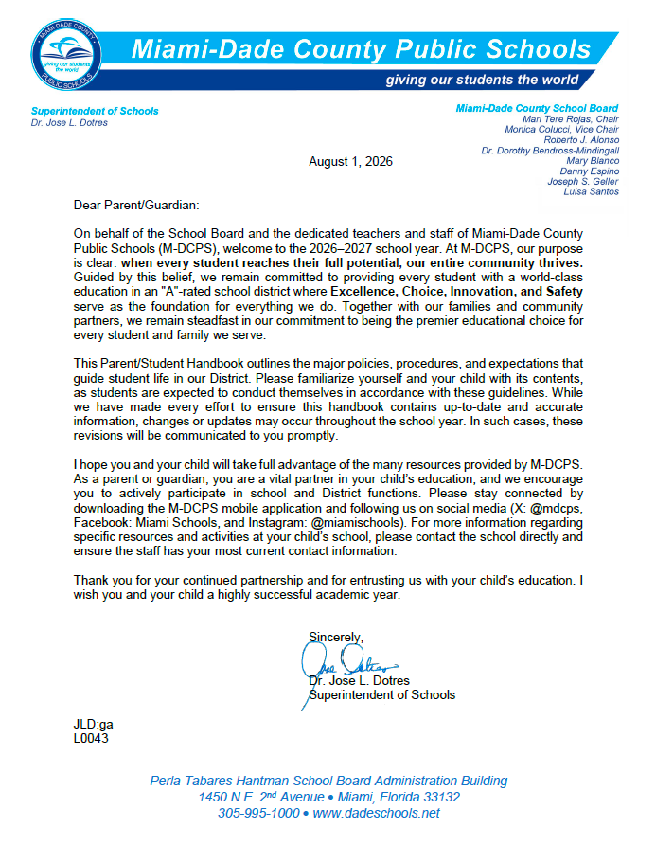

TABLE OF CONTENTS

Message from Principal

Message from Assistant Principal

School’s Mission Statement

Faculty Roster

Feeder Pattern Schools

School Information
- Bell Schedule
- Early Sign Out
- Late Arrival
- Lost and Found School Policy
- Opening and Closing Hours of Schools

Important Dates
- Back to School Nights - Open House
- Interim Progress Report & Report Card Availability
- School Calendar of Events

Academic Programs – Student Progression Plan (SPP)

Alumni305

Arrival/Dismissal

Before/After School Care Program & Middle School Enrichment After School Program

Birthdays

Bring Your Own Devices (BYOD)

Bullying Prevention

Clinic

Closing of School

Code of Student Conduct

Community School Program

Comprehensive Student Services Program

Discrimination/Harassment

Dismissal

Early Dismissal

EESAC

Elevator

Emergency Contact Information

Exceptional Student Education/Section 504

Fieldtrips

Homework

Instructional Materials

LGBTQ Support

Mealtime Environment
- Free Breakfast
- Meal Program Information
- Meal Prices
- Peanut-Allergies/Peanut-Free School

Mental Health Services

Newsletter
- Connection Newsletter

Prekindergarten Programs

Protocols for Addressing Concerns

Public-Private Collaboration

Recess

Safety and Security
- Emergency Operations Plan
- Fire Drills
- Emergency Drills
- Lockdown Procedures
- Threat Assessments
- Visitors

School Activities/Clubs

School Class Pictures Process

School Transportation

Student Records

School Volunteer Program

The M-DCPS Parent Academy

Uniform Policy

Verification of Residency

Appendix A - School Calendars

Appendix B – Florida Statutes and School Board Policies

Appendix C – Parents’ Bill Of Rights

Appendix D – FortifyFL

Appendix E - Discrimination/Harassment Poster and Policy

Appendix F – Standard Response Protocol

Appendix G – Dadeschools Mobile App

Dear Parents/Guardians,

It is with great excitement that we welcome you back to the OHE family for the 2026-2027 school year! We are extremely proud of the work done by our students, parents, and teachers. Because of their hard work, Olympia Heights continues to be a high performing school.

We hope to build on the support and successes of last year and look forward to our continued partnership. As your principal, I will continue to cultivate a school culture where all educational programs are conducive to student learning and development. As we begin the 2026-2027 school year, we must continue to set the bar for our goals high and surpass our greatest expectation.

With the new school year comes a new sense of excitement and anticipation. Our academic focus will be classrooms that are guided by literacy, problem solving, critical thinking, hands-on science and writing. In order to adequately prepare our students for secondary school and beyond, we feel strongly that these principles are necessary for student success.

We hope to collaborate with all of you to find ways to provide our students the finest educational experience in our school system. If know we will find ways to SADDLE UP FOR SUCCESS AT OHE this school year! We will all come together in the name of our students to meet the challenges that face us each school year.

I, once again, want to express my sincere appreciation to all of you for your pledge and commitment to the success of all our students. I am proud to lead the amazing team of Olympia Heights Elementary through another wonderful school year.

Sincerely,
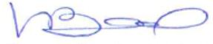
Victoria Bourland, Principal

Dear Parents/Guardians:

Welcome to the new 2026-2027 school year! It is my honor to extend a warm welcome to all of our students and their families, both returning and new to our Olympia Heights Elementary family. This new school year represents a new opportunity to grow, learn, and build together a positive and nurturing environment for all. At OHE, we are committed to providing quality education in a safe, inclusive, and motivating setting.

We know that parent involvement is critical to our students' success. That's why we encourage you to stay involved, communicate with teachers and staff, and be an active part of school activities. Together we make a great team, and mutual support will be key to achieving great things this year. Thank you for being part of this great family. We are happy to begin this new chapter with you at OHE... where we Saddle Up for Success!

Thank you.
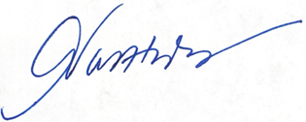
Ariadna Valdes-Hernandez
Assistant Principal

Olympia Heights Elementary


VISION
Olympia Heights Elementary provides its students, parents, and community with access to a state-of-the-art comprehensive curriculum designed to support the academic needs and values of all the stakeholders.

MISSION
The goals at Olympia Heights Elementary are designed to enable students to achieve their potential, foster a respect for the cultural heritage of the nation, promote social-emotional learning, and become contributing members of society through a well-rounded education that involves critical thinking, modern technology and active participation of students, parents, and community members.

Faculty Roster
Mrs. Victoria Bourland, Principal
Mrs. Ariadna Valdes-Hernandez, Assistant Principal

Pre-K PK Paraprofessional
Cecilia Paton Cynthia Miranda-Warren

ESE Teachers
Kindergarten Sarah Lane
Desiree Aleman Karla Sanchez
Karina Bolivar
Annette Vega
First Grade
Nilda Lopez Teachers of the Gifted
Lourdes Mestre Liza Diaz
Stephanie Montoya Ara Gornail

Second Grade ESE Paraprofessional
Cynthia Vivas Patricia Acevedo
Rebecca Bonet

Title I Interventionist
Third Grade Vicky Silva
Priscilla Guerrero
Janeth Cano Clerk
Rosario Guerrero
Fourth Grade
Gloria Valdes
Maria Imperatori BIlingual
Lourdes Mestre - ESOL
Marta Dominguez - Spanish
Fifth Grade Fabiana Noriega - Spanish
Sadie Clark
Anita Fernandez/Nicole Grainger Special Areas
Gloria Parlade – Art
Media Specialist Lupe Perea Sotolongo - Music
Stephanie Montoya Alain Alvarez – PE

Counselor Speech Pathologist
Yolanda Sanchez Alina Paz

Social Worker School Psychologist
Digna Cid Jacqueline De Leon

Feeder Pattern Schools
Elementary Schools
Blue Lakes Elementary
Dr. Carlos J. Finlay Elementary
Wesley Matthews Elementary
Olympia Heights Elementary
Royal Palm Elementary
Tropical Elementary

K-8 Centers
Cypress K-8 Center

Middle/High School
Riviera Middle School

High School
Miami Southwest Senior High School
Ruth Owens Kruse Educational Center
Brucie Ball Educational Center

School Information
- Early Sign Out
The early release of students causes disruption to the academic performance of all students and may create safety and security concerns. No students shall be released within the final thirty (30) minutes of the school day unless authorized by the Principal or Principal’s designee (i.e., emergency, sickness).

- Late Arrival
Students who are tardy to school must report to the Main Office to secure an admit. Excessive tardies may result in loss of privileges, detention, parent conference, and/or suspension.

- Lost and Found School Policy
Items, clothing, etc. found will be placed in a designated area located in the cafeteria.

- Opening and Closing Hours of Schools
Miami-Dade County Public Schools opening and closing hours for students are as
follows:

GRADE 2017-2022 SCHOOL HOURS
Pre-K, K, 1st 8:20 a.m. - 1:50 p.m.
2nd – 5th 8:35 a.m. – 3:05 p.m.
ALL Grades DISMISSAL AT 1:50 P.M. ON WEDNESDAYS

Important Dates
- Back to School Nights – Open House
School Level | Window Period | School Date
Elementary/K8 Center | Week of August 24, 2026 | August 26, 2026

- Interim Progress Report & Report Card Distribution
Grading Period | Interim Progress Report Distribution | Report Card Available in the Portal no later than
1 | September 18, 2026 | October 23, 2026
2 | November 19, 2026 | January 22, 2027
3 | February 19, 2027 | April 2, 2027
4 | April 30, 2027 | June 10, 2027

- School Calendar of Events
Monthly Calendar of Events will be sent home with students and placed on the school website.
Academic Programs – Student Progression Plan (SPP)
Provides guidance to teachers, school and district administrators, parents and other stakeholders regarding the requirements and procedures for students to progress from one grade to the next, kindergarten through grade 12 and adult education. The information presented in this document is derived from requirements set forth by Florida Statues, State Board of Education Rules and Policies established by The School Board of Miami-Dade County.

Alumni305 – Did you attend a Miami-Dade County public school during your K-12 education? If yes, we want you to be part of Alumni305, a new way to connect with your former classmates and alma maters. Visit mdcpsalumni.dadeschools.net and sign up.

Arrival/Dismissal
Morning Arrival/Supervision
- Parents are not permitted to drop off students at their classrooms.
- Parents who drive students to school will use the drop off lane in front of the school. The
movement in this lane should be continuous. Drivers should only stop long enough to safely allow passengers to disembark. Parking in this area is not permitted.
Parents who walk students to school will drop off students at the front of the school.
- Olympia Heights’ staff members as well as Safety Patrols will be located throughout the
campus to assist student who arrive late.

Breakfast
- Parents are not permitted in the cafeteria for breakfast.
- The building will open at 7:45 am for student arrival for breakfast.
- Breakfast will only be available for students.

Dismissal
- PK-5th grade students will be dismissed in front of the main building using the outer loop of the driveway. On Wednesdays, Pk-2nd grade will be dismissed using the outer loop and 3rd-5th will be dismissed using the inner loop/
- Each student will be assigned a dismissal number.
- Each parent will receive a dismissal car sign with their child’s assigned number. They will place the sign on the car’s dashboard. A school employee with call for the child by their assigned number. Teacher will then send the student down for dismissal.
- Parents are to wait in their vehicle.
- Parents who walk will wait at the end of the covered walkway.

The safety of our Olympia Heights Elementary students is everyone's job. If students are to be kept safe, everyone (parents, staff, and students) must cooperate by following all school procedures and being patient and cautious at all times. It is important to understand that there is no supervision for students prior to 7:45 am. Please remember to use crosswalk when crossing the street.

Rainy Day Dismissal: Procedures will remain the same when it is a rainy day. If it is lightning, dismissal will be paused until it is safe to resume.

Before/After School Care Program & Middle School Enrichment After School Program
For those parents considering going back to work and/or are presently working, there are 240 low cost Before and After School Care programs that serve both Elementary and K-8 Center students and 54 Middle School Enrichment After School programs that help tutor middle school students throughout the Miami-Dade County School district. Each of these programs are staffed with state certified instructors, state certified program managers, or state certified activity leaders who are all prepared to enrich and expand the after-school experience of the students they serve.
This year, Miami-Dade County Public Schools will offer 294 After School programs on school days. Before-school care programs will be provided as needed.
After-school care programs are conducted from the time of school dismissal until 6:00 p.m. Before-school care programs begin approximately one hour before school starts. Summer Camp operates from 7:00 a.m. until 6:00 p.m. Parents should check with their child's school for specific start times.
All after-school care programs provide planned activities, which include homework assistance, indoor and outdoor games, arts and crafts, snack time and various recreational activities. Many programs offer reading and math tutoring, music, ceramics, chess, drama and other classes designed to provide participants with a variety of educational and enrichment experiences. Before-school care programs provide supervised, quiet activities for students.
The cost of Elementary and K-8 after school care is $60 per week or $55 per week discounted rates for sibling or free/reduced lunch discounts; the cost of Middle School Enrichment after school care is $60 per week and $55 per week discounted rates for sibling or free/reduced lunch discounts; the cost of before school care is $30 per week and the cost of Summer Camp is $125.00 per week or $115 per week discounted rates for sibling or free/reduced lunch discounts. These programs are offered by one of five providers:
- Miami-Dade County Public Schools Principal Operated Before After-School Programs
- Young Men's Christian Association (YMCA)
- Young Women's Christian Association (YWCA)
- Family Christian Association of America (FCAA)
- South Florida After-School All Stars (SFASAS)

Birthdays
No birthday parties/celebrations are permitted- no cupcakes/cakes or other food items allowed.

Bring Your Own Device (BYOD)
Bring Your Own Device allows students, parents, staff and guests utilize technology devices at specified times during the instructional day to enhance the learning experience. Examples of the types of technology which can be used are Windows laptops/tablets,
Mac laptops, Android tablets, and iPads. More information about the BYOD program as well as minimum device specifications for those that are considering purchasing a device can be found at https://digital.dadeschools.net

Bullying Prevention
Miami-Dade County Public Schools is committed to providing a safe learning environment for all students and therefore all allegations of bullying/harassment are taken seriously. When concerned about bullying or harassment behaviors, contact your child’s teacher immediately. You can verbally report your concerns and/or fill out the Bullying and Harassment Reporting Form. If the problem should continue to persist, notify the school’s principal. You may also contact the Bullying/Harassment Helpline, staffed by the Division of Student Services staff at the District office. They can be reached at 305-995-CARE (2273). The Helpline is staffed from 7:30 a.m. - 4:30 p.m., Monday through Friday. Students and parents may also report bullying through our Districts anonymous online bullying reporting system available on the student and parent portals. Additional information regarding bullying and harassment can be found on the Student Services website.

Clinic
The clinic will be used for students who are ill. The nurse will contact parents or persons named in the emergency contact information. No medication or treatment may be administered by any school personnel. No child may bring or take any medication unless proper documentation is on file in the office, and only under supervision of trained personnel.
Closing of School
The emergency closing of a school for any cause, such as weather or in which the safety of individuals may be endangered, is only at the discretion of the Superintendent of Schools.
Code of Student Conduct
Miami-Dade County School Board approved a revised Code of Student Conduct (COSC). The COSC focuses on providing and maintaining a safe and positive learning environment for students, faculty, staff and community.
A major consideration in the application of the Code of Student Conduct is cultivating a positive school climate to support academic achievement, promote fairness, civility, acceptance of diversity, and mutual respect. Toward that end, the range of inappropriate behavior is divided into five groups, along with both recommended and mandated corrective strategies.
The Code of Student Conduct addresses the role of the parents/guardians, the students, and school, but also focuses on core values and model student behavior, rights and responsibilities of students, addressing student behavior, and disciplinary procedures. Furthermore teachers, counselors and administrators work to use a variety of progressive corrective or guidance strategies to correct the inappropriate behaviors.
Differences in age and maturity are recognized in determining the types of corrective strategies to be taken. However, the procedures outlined in the COSC apply to all students under the jurisdiction of Miami-Dade County Public Schools. The COSC is in force during regular school hours, while students are being transported on a school bus and at such times and places – including but not necessarily limited to school-sponsored events, field trips, athletic functions and other activities – where appropriate school administrators have jurisdiction over students.
Principals are authorized to take administrative action whenever a student's off-campus conduct poses a threat or danger to the safety of other students, staff, School Board members, any other members of the District Community, or school property may constitute behavior that has a substantial adverse impact on the educational environment requiring disciplinary action. Types of behaviors range from acts that disrupt the orderly operation of the classroom, school functions, and extracurricular activities or approved transportation to the most serious acts of misconduct and violent actions that threaten life.
The Code of Student Conduct outlines expected student behavior and a multitude of corrective strategies should misconduct occur.
The COSC addresses students' rights and responsibilities pertaining to the right to learn; attendance; students' records; grades; free speech, expression and assembly; and publications. It also outlines parents' rights in regard to assuring their child's opportunity for an education.
Students or parents having problems interpreting the COSC should address concerns through the school principal. Additionally, should the concerns not be resolved at the school level, an appeal can be made at the region office and subsequently to the District.
The Code of Student Conduct can be accessed by going to the following website: http://ehandbooks.dadescholgbtols.net/policies/90/index.htm. If you do not have access to the Internet, you may go to your child’s school and request to review the Code of Student Conduct manual.
Please take the time to review and discuss the importance of the Code of Student Conduct with your child or children. After reviewing the Code of Student Conduct, you and your child/children must sign, date, and return the accompanied Parent Receipt and Acknowledgement Form to your child's school within 5 school days.
Community School Program
The Community School Program offers an opportunity for the public-school system to determine the needs of the community and provides a mechanism to meet those needs. The curriculum of the Community School Program is as wide and varied as the needs of the community it serves. Community schools provide programs that are funded by fees, tuition, grants, and donations, on community school sites, in adult centers, in satellite programs, and at off-campus, non-public school locations throughout Miami-Dade County.

Each of the 17 Community Education Centers offer classes for individuals of all ages, skill levels and language capabilities. Students enrolling in language or computer classes have the opportunity to enhance the job skills needed to satisfy the demands of today’s world. Annually, thousands of people have taken advantage of these recreational and educational opportunities, and if an individual or group wants to acquire a specific new skill, Miami-Dade County Public Schools can work with each to create a class that suits the needs of all interests.

For more specific information on Miami-Dade County Public Schools Community Education and Before and After School Care programs or Middle School Enrichment After School programs, please log on to our website at www.dadecommunityschools.net or call the Office of Community Education, at 305-226-6565 ext. 2155.

Comprehensive Student Services Program
The Division of Student Services implements the Comprehensive Student Services Program,
serving students from Pre-K to Adult. Through collaborative efforts with community agencies,
students’ academic, personal/social and career development needs are addressed through a
team-based approach. An integrated team of uniquely trained Student Services professionals
deliver direct services to students. These services focus on the elimination of social and
emotional barriers that inhibit students’ academic success and prepare students to be college
and career ready.

The Comprehensive Student Services Program supports student achievement through
effective prevention, intervention, and crisis response services. For more information, please
contact Martha Z. Harris, Administrative Director, Division of Student Services, at 305-816-
0436.

Discrimination/Harassment
The School Board has a prohibition against discrimination and harassment based on age, citizenship status, color, disability, ethnic or national origin, Family Medical Leave Act (FMLA), gender, gender identity, genetic information, linguistic preference, marital status, political beliefs, pregnancy, race, religion, retaliation, sexual harassment, sexual orientation, social/family background, and any other basis prohibited by law. Students are encouraged to promptly report incidents of discriminatory or harassing conduct to their principal or the Office of Civil Rights Compliance (CRC) so that the conduct can be addressed before it becomes severe, pervasive, and persistent. For more information, please contact CRC at (305) 995-1580 or visit http://hrdadeschools.net/civilrights.

The School Board has also adopted a policy Against Bullying and Harassment with Bullying defined by state law as systematically and chronically inflicting physical harm or psychological distress on one or more students. Complaints of bullying should be reported to the principal promptly. You may also contact the Bullying/Harassment Helpline, staffed by the Division of Student Services at the District Office. They can be reached at 305-995-CARE (2273). The Helpline is staffed from 7:30am-4:00pm Monday through Friday.

Early Dismissal
In the case of divorced or separated parents, the enrolling parent shall indicate on the Emergency Student Data Form the individual(s) to whom the student may be released during the school day.

EESAC
The Educational Excellence Advisory Council (EESAC) is the sole body responsible for final decision making at the school relating to the implementation of the components of the School Improvement Plan. The EESAC work together to accomplish the goals of the school by:
- Assisting in the preparation and evaluation of the schoolwide improvement plan (SIP)
- Approving the use of school improvement funds to support implementation of the SIP
- Assisting in the preparation of the school’s annual budget.
Educational Excellence School Advisory Councils (EESACs) and other advisory meetings held by schools are listed in the Miami-Dade County Public Schools' Meeting Directory.
Elevator
The school elevator is to be used by individuals who are disabled or injured and cannot use the stairs.

Emergency Contact Information
Emergency Student Data Forms are distributed during the first week of school. Students are expected to bring the forms home and present them to their parents/guardians. The form must be carefully completed and returned. The form must be completed and signed by the registering parent. The information provided on the Emergency Student Data Forms will enable school staff to contact the parent/guardian immediately in the case of an emergency. Parent/Guardian(s) that provide a cell phone number will receive text messages should an emergency arise. Students may only be released from school to the persons listed on the form after presenting a picture identification. No persons, other than student’s parent(s) and school staff, will have access to the information submitted

The school shall abide by information provided by the registering parent who must sign the Emergency Student Data Form and name individuals who are authorized or unauthorized to pick up a student from school. Any person verified as a parent in the District’s Student Information System is presumed to be authorized to pick up the student unless otherwise indicated on the Emergency Student Data Form by the registering parent. The registering parent who completes the Emergency Student Data Form is responsible for providing information that is truthful and accurate – and in the case of unmarried, divorced, or separated parents, consistent with any court order in effect governing their divorce, separation, or parenting matters. Any parent contesting the information provided in the Emergency Student Data Form by another parent may seek assistance from the court governing their parenting matters to compel the registering parent to revise the information. School staff shall provide such persons with the website for the Family Court Self-Help Program at http://www.jud11.flcourts.org/Family-Court-Self-Help-Program. Parents may agree to change the registering parent and submit an Agreement to Change of Registering Parent Form (FM-7600) at any time.

Anyone who knowingly makes a false statement in writing with the intent to mislead a public servant in the performance of his/her official duty is guilty of a second-degree misdemeanor under F.S. 837.06. In addition, anyone who knowingly makes a false verified declaration is guilty of perjury, a third-degree felony under F.S. 92.525.

The registrar/attendance clerk will also be notified of any transfer or withdrawal so that the files may be purged as changes occur. In addition, changes of address must be reflected on student records.

Exceptional Student Education/Section 504
The School Board of Miami-Dade County, Florida ensures that all students suspected of having a disability are identified, evaluated, and provided appropriate, specially designed instruction and related services, if it is determined that the student meets the state's eligibility criteria and the parent/guardian consents to initial placement.

Students who are not eligible for specially designed instruction and related services in accordance with state eligibility categories but have a disability that substantially affects a major life activity may be eligible for accommodations pursuant to Section 504 of the Rehabilitation Act of 1973.

As the parent/guardian of a child with disabilities, you are a very important member of the team that plans your child's education. Be informed and get involved. If you have any questions, please contact your child's school and/or the Office of Educational Services and ESE at ESE@dadeschools.net. Staff from the Office of Educational Services and ESE and/or your child's school site administrative team will help to answer your questions. Additional information may also be found at http://ese.dadeschools.net/.

Fieldtrips
All fieldtrips must be approved by the principal and Region Superintendent., as applicable Participation in fieldtrips requires that the student present a fieldtrip form signed by the parent/guardian to his/her teacher(s) in advance.

Homework
Principals are encouraged to work with teachers and parents to implement guidelines found in Homework Policy 2330. Teachers are required to provide students with make-up assignments once the absence has been excused; however, it is the responsibility of the student to request the assignments from the teacher(s).
OLYMPIA HEIGHTS ELEMENTARY SCHOOL - HOMEWORK POLICY

Olympia Heights Elementary recognizes that one of the main purposes of the elementary school is to begin training in the habits of independent study by establishing good work habits and reinforcing skills. This can be done by making assignments that can be carried out without the supervision of the teacher. The responsibility becomes a threefold goal: teacher, student and parents.

Teacher Responsibilities
- The teachers will show evidence of homework assignments in their lesson plans.
- The teachers will check and review the assigned homework. Homework
assignments will not be given as punishment or as busy work.
- The teachers are to give homework assignments that are well within the capabilities of
students, and can be adapted to individual needs, interests and capacities.
- The teachers are to make sure assignments are clearly understood by student and can
be done by the student without help from others.
- Homework assignments will be checked, or graded, and recorded in the gradebook.

Student Responsibilities
- The student is to ask questions pertaining to the assignment during the time the
assignment is given or at the teacher’s convenience.
- The student must put forth his/her best effort to do the homework assignment and to
complete it by the due date.
- The student is to turn in the completed assignment in an acceptable manner to his/her
teacher.
- The student is to copy all assignments in her/his assignment book, and bring home
necessary books and materials.

Parent Responsibilities
- The parent is to provide appropriate time and space free from interruption in order for the
student to be able to concentrate without disturbance.
- The parent should encourage the child to finish the assignment or do the required amount
of study for the evening.
- The parent should be available for advice or consultation; however, the student should
assume the ultimate responsibility.

The homework policy of the Miami-Dade County School Board emphasizes the importance of reading and encourages parents to become involved in the implementation of the homework guidelines, which include a marked emphasis on reading.

One way that parents can support a renewed emphasis on meaningful homework is to ensure that their children read daily. Of course, parents or other family members should make every effort to read to students who cannot read on their own.

The recommended daily homework averages are as follows:
Grade Level Frequency of Assignments Total Daily Average (All Subjects)
K – 1 Daily (5 days a week) 30 minutes + 30 minutes daily reading
2 – 3 Daily (5 days a week) 45 minutes + 30 minutes daily reading
4 – 5 Daily (5 days a week) 60 minutes + 30 minutes daily reading

All students must read 30 minutes daily in addition to regular homework assignments.

Instructional Materials
Parents that would like to express concerns regarding any educational/library materials may file on objection regarding non-adopted instructional and library/media center and other educational materials by visiting the Instructional Materials link under the parent tab at their school’s website or by clicking on the Instructional Materials link on the Dadeschools website.

LGBTQ Support
The School Board of Miami-Dade County has adopted comprehensive anti-discrimination and anti-bullying policies that require all students be treated with respect regardless of their unique characteristics, including sexual orientation. Every student has the right to learn in a safe and accepting school environment and schools have a responsibility to provide a safe and nondiscriminatory environment for all students. M-DCPS has established the Students Allies for Equity (SAFE) Network with liaisons in every school who are trained to ensure that all students have access to all aspects of school life in ways that preserve and protect their dignity.

Mealtime Environment
School lunchtime should be an opportunity to encourage healthy lifestyle, promote socialization that will affect early behaviors.

The Department of Food and Nutrition serves healthy meals daily. Please visit nutrition.dadeschools.net for details on menus, programs, and services.

- Free Student Meals
All students enrolled in district managed sites will have access to school meals at no charge.
- Meal Program Information
All school meal program flyer with information for parents will be posted on the school’s website and at nutrition.dadeschools.net.
- Meal Prices
Breakfast | Lunch
All Students No Charge | All Students No Charge
Adults $ 3.00 | Adults $ 5.00
- Peanut Allergies/Peanut-Free School
Parents/Guardians should notify the school principal of any allergy or other medical condition their child has and request the appropriate forms for completion.

Mental Health Services
Miami-Dade County Public Schools established The Department of Mental Health Services to expand school and community-based mental health services and resources to ensure ongoing coordination of services to further support the emotional and mental well-being of students. The programs in place provide prevention initiatives, intervention services for students and family support for students who may be experiencing a mental health challenge. Students in need of intensive services can receive support from contracted agencies at no cost to families. For assistance contact your child's school, the Parent Assistance Line at (305) 995-7100 or visit https://mdcpsmentalhealthservices.net/.

School principals shall make a reasonable attempt to notify a parent of a student before the student is removed from school, school transportation, or a school-sponsored activity to be taken to a receiving facility for an involuntary examination and school or law enforcement personnel must make a reasonable attempt to contact a mental health professional prior to initiating an involuntary examination, except where there is an imminent danger to the student or others.

Newsletters
- Connection Newsletter
M-DCPS Office of Communications publishes a monthly newsletter dedicated to M-DCPS parents. Please visit https://www.engagemiamidade.net/families where you can find the latest issue as well as archived issues from the previous year.

Prekindergarten Programs
M-DCPS offers a variety of prekindergarten programs throughout the District. Parents should contact their home school for the available options for Pre-K students. For additional information on VPK or Head Start/Early Head Start Programs, parents may contact the Department of Early Childhood Programs at 305-995-7632. Parents may also access information at https://earlychildhood.dadeschools.net/#!/fullWidth/3451. For information on Pre-K ESE Programs, parents should contact 305-271-5701 or visit prekese.dadeschools.net to learn more about programming for children with disabilities. Families should also feel welcome to reach out to us at ESE@dadeschools.net with questions and concerns.

Protocol for Addressing Parental Concerns
Parents may generally address their complaints or concerns to the school administration, which may be followed by Region and District department review by appropriate. For issues involving an individual teacher or class, parent/guardian address their concerns to the following individuals in the order below.

Public-Private Collaboration
Requests for private instructional personnel to collaborate with public instructional personnel in the educational setting should be directed to the principal for application of District procedures.

Recess
Recess is supervised, unstructured playtime where children have choices, develop rules for play and release energy and stress. Recess will be conducted outdoors when weather permits. In the case of inclement weather, appropriate recess activities will be conducted indoors.
Schools shall provide at least 100 minutes of supervised, safe, and unstructured free-play recess each week for students in kindergarten through grade 5, so that there are at least 20 consecutive minutes of free-play recess per day.

Safety and Security
- Emergency Drills
Six emergency drills, to include active shooter, hostage situations, bomb threats, and other potential emergencies will take place during the school year in accordance with Florida Administrative Code 6A-1.0018(15). All occupants of building where an emergency drill is held are required to participate. The first emergency drill must take place within the first 10 days of the opening of schools, whereas all remaining drills must occur at least every 45 days that school is in session. All emergency drills shall be conducted in accordance with the appropriate corresponding situational response as outlined in the EOP and shall include developmentally appropriate and age-appropriate procedures.
- Emergency Operations Plan
Student and employee safety is a primary concern of the Miami-Dade County Public School (M-DCPS) System. The Emergency Operations Plan (EOP) was created to provide school personnel with the necessary leadership skills and knowledge needed to respond to critical incidents or other related emergencies that may occur in our schools/community. All schools have a site-specific plan to address all types of critical incidents. These plans address the individual needs of the school and provide guidelines for devising methods for communicating with the staff, students, parents/guardians, and the media during a critical incident or an emergency. Some of the protective action procedures include emergency drills (active shooter, hostage, & bomb drills), the evacuation of students/staff from the building(s), evacuation of the disabled and if necessary the relocation of students/staff from the school campus, lockdown procedures and holding/dismissing students during school and community emergencies. Some important tips for parents/guardians to remember during a Critical Incident are as follows:
- Remain calm;
- Monitor media outlets for updates and official messages from M-DCPS;
- Do not flood the school with telephone calls; and
- Students will not be released during a lockdown. If you need to pick up your child, wait until the lockdown in lifted before going to the school.

All school administrators, Region Center Superintendents/Directors and all MDSPD Police officers have been adequately trained in the school EOP and are prepared to respond immediately during a critical incident or emergency to provide safety for all children.
FortifyFL (flyer in Appendix D)

- Fire Drills (Evacuation Drills)
Evacuation drills will take place during the school year in accordance with the National Fire Protection Association 101 Life Safety Code. When the fire alarm activates, students must stop what they are doing and follow the teacher’s instructions. Students must clear the building promptly by the prescribed route. Any student who is in the hallway or the restroom must proceed to the nearest exit and locate the teacher. Students, teachers and staff must remain outside the building until permission is given to re-enter.

- Emergency Drills
Twenty-one emergency drills, to include one monthly active shooter drill and one hostage situation or bomb threat drill, will take place during the school year according to Florida Senate Bill 7026, also known as the Marjory Stoneman Douglas High School Public Safety Act. One additional active shooter drill must take place within the first 30 days of the opening of schools. All emergency drills shall be conducted in accordance with the appropriate corresponding situational response as outlined in the EOP and shall include developmentally appropriate and age-appropriate procedures.

- Standard Response Protocol
During the Fall of the 2023-2024 school year, Miami-Dade County Public Schools adopted the Standard Response Protocol and uses the Standard Response Protocol (SRP) to communicate during emergencies or critical incidents. The SRP is a set of five actions using clear common language that everyone in our school, including students and staff, follow in case of an emergency or critical incident. These actions are HOLD, SECURE, LOCKDOWN, EVACUATE, and SHELTER. Refer to the Appendix to access the SRP Parent/Guardian flyer (Appendix “F”). In addition, parents/guardians can also access the SRP flyer in the parent portal.

- Threat Assessments
Miami-Dade County Public Schools (M-DCPS) has a mandated set of procedures for threat assessment. Schools must establish a Threat Assessment Team (TAT) comprised on an administrator, counselor, teacher, and law enforcement officer. A threat assessment is a problem-solving approach to violence prevention that involves assessment and intervention with students who have threatened violence in some way. When a preliminary determination is made, by the school administrator or designee, that a student poses a threat of violence or physical harm to him/herself or others is known, a TAT shall be notified and shall convene to determine the best course of action. Authorized members of the TAT may obtain criminal history record information, if applicable. Students determined to be at-risk for violence will be referred for mental health services. Threat assessment and disciplinary procedures are separate processes. Regardless of whether a threat is determined to be transient, serious substantive, or very serious substantive, appropriate disciplinary procedures shall be followed in accordance with the Code of Student Conduct.

- Visitors
Due to legal regulations, students are not permitted to have guests attend school with them at any time. Parents/guardians are always welcome, and tours may be arranged with the principal to view the school. Classroom visits require a request with 24-hour notice. All visitors must first register with security at the main entrance, sign-in, produce photo identification, and then proceed to register in the main office. Anyone who fails to follow these procedures will be considered a trespasser and is subject to arrest.

School Activities/Clubs
All School Activities, clubs, and organizations must be approved by the principal and conform to the School Board Policies 5845 - Student Activities, 5830 - Student Fundraising and 9211 – Parent Organization, Booster Clubs, and Other Fund-Raising Activities.
- Clubs
Miami-Dade County Public Schools’ students may participate in a wide variety of activities, including student council, subject-area clubs, honor societies, service clubs, school publications and class activities. School-sponsored clubs may be curriculum-related or noncurricular-related.

Curriculum-related clubs are student groups whose goals are an extension of the activities and objectives in a particular subject area within the school's curriculum. Conversely, noncurricular-related clubs are student groups whose goals are special interest oriented and not directly related to the curriculum. Meetings of noncurricular-related clubs may be scheduled only at times when instruction is not taking place, either before or after school.

- School Club List
  - Chess

School Class Picture Process
The school class picture monies will no longer be collected by school staff for this activity. Collection of monies will be conducted by the photographer and/or photographer’s staff.
At no time, shall a staff member, parent, volunteer, or member of a school-allied organization such as the PTA handle school class picture monies.

School Transportation
Miami-Dade County Public Schools will transport approximately 35,000 students a day this school year, using a fleet of 999 buses on 800 school-bus routes. The service is for students who live more than two (2) miles from their assigned school and for students with special needs in some instances.

Before school begins, parents/guardians of all students eligible for bus transportation should log on the BusPlannerWeb and view the bus assignment. The information is updated nightly, and a link is provided on the parent portal. Parents/guardians are encouraged to check the BusPlannerWeb throughout the school year to obtain the most current information on their children’s bus assignment.

Parents interested in determining their child's transportation eligibility should contact their child's school for information.

Student Records
The education records and personally identifiable information of students are protected by The Family Educational Rights and Privacy Act (FERPA) and the Florida Statutes. These laws provide that without the prior consent of the parent, guardian or eligible student, a student's records may not be released, except in accordance with the provisions listed in the above-cited laws. The laws provide certain exceptions to the prior consent requirement to the release of student records, which include, but are not limited to, school officials with a legitimate educational interest and lawfully issued subpoenas and court orders with notice prior to disclosure. Parents and eligible students are also provided the right to challenge the accuracy of their education records in accordance with the procedures outlined in School Board Policy 8330.

Each school must provide to the parent(s), guardian(s) or eligible student(s) an annual notice in writing of their right to inspect and review student records. Once a student reaches 18 years of age or is attending an institution of post-secondary education, the consent is required from the student only, unless the student qualifies as a dependent under the law.

School Volunteer Program
The School Volunteer Program matches the resources of members of the community with the needs of our schools to support the District's goal of student achievement. School Volunteers bring with them many diverse skills and talents that are tailored to the needs of the students and the community. Each year, more than 30,000 volunteers share their time and talents enriching the lives of students in our schools.
To Become a School Volunteer:
- Visit https://www.engagemiamidade.net/volunteers
- Complete the online volunteer registration (Raptor).
- Receive email approval from the School Volunteer Office.

Once you're approved, CHECK-IN at your school as a VOLUNTEER to track your time and school volunteer activity.

Steps to Managing Your Volunteer Hours

Who Can Volunteer?
- Students- M-DCPS students; college/university students charter/private school students
- Parents - Guardians, primary caregivers
- Employees - Administrators, teachers, and staff of M-DCPS;
- Community Members and Organizations - businesses, retirees, local organizers, community and faith-based organizations, alumni, and college students

The M-DCPS Parent Academy
Miami-Dade County Public Schools created The Parent Academy to bridge the gap between home and school by connecting parents to valuable resources and information on topics that impact children’s lives, including helping children learn, parenting skills, financial management, and health and wellness.

The Parent Academy supports parents in becoming more involved in their children’s education and empowers them to set and achieve personal empowerment goals for higher education and career advancement by providing free, year-round workshops, classes and events at schools, neighborhood centers, and community agencies across the county.

Parents can participate in virtual and in-person sessions that are aligned to their needs and convenient to their homes and workplaces. Upcoming events and workshop offerings are listed on the M-DCPS Parent Academy website at parentacademymiami.com. For additional information, please call the M-DCPS Parent Academy at 305-271-8257 and follow them on Facebook and Instagram “Parent Academy Miami” and on Twitter “@ParentAcadMiami”.

Uniform Policy
To promote a safe and supportive learning environment and improve school safety and discipline, all students in K-8 schools shall participate in a mandatory uniform program.
Tops
Hunter green, yellow or white polo shirt
- Tank tops and shirts exposing the stomach area are not allowed.
Bottoms
Khaki slacks/pants (loose fitting), skorts, or shorts.
- Slacks/pants must be worn at the waistline with a belt.
Shoes
- CLOSED shoes and socks are required as students participate in Physical ducation and/or Recess daily.
Students will not be allowed to wear the following articles of clothing:
- Spandex material pants/ or skirts
- Hats, bandanas or sweat bands
- Flip-flop sandals, clogs, or other shoes without back straps
- Written messages, pictures or symbols on clothing that portrays ideas which are inimical to the health, safety and welfare of students e.g., messages which relate to drugs, smoking, alcohol, sex, and profanity.
- Clothing with metal studs, chains, ornaments, or other objects which can scratch furniture, damage property, or cause bodily harm.
- Halter tops, tube tops, tank tops, see-through blouses or shirts, bare backs, bare midriffs, sleeveless t-shirts
- Shorts, sweat pants, biker shorts, or Capri pants
- Short dresses or skirts rise above the knee.
- Denim or jean pants or skirts, and overalls
- Accessories and/or gloves that cover hands, wrists, and/or neck are prohibited

Verifications of Residency
If verification is not provided or acceptable, the Superintendent may verify the student's residence.

Wireless Communication Device (WCD) Use Policy
In accordance with state law, students in elementary and middle schools (grades pre-kindergarten – 8th) are not permitted to use or display personal wireless communication devices during the school day unless an exception applies. High School students (grades 9th – 12th ) may display and use their personal wireless communication device during the school day, but may not use their personal device during instructional time unless expressly directed by a teacher solely for educational purposes.

The school is not responsible if a student’s wireless communication or any electronic device or personal device is lost or stolen. For information about exceptions to the wireless communication device rules, parents may refer to School Board Policy 7540.03 – Student Responsible Use of Technology, Social Media, and District Network Systems & Internet Safety, and the applicable Code of Student Conduct.

Anyone who knowingly makes a false statement in writing with the intent to mislead a public servant in the performance of his/her official duty is guilty of a second-degree misdemeanor of the second degree under Florida Statute 837.06. In addition, anyone who knowingly makes a false verified declaration is guilty of perjury, a third-degree felony under Florida Statute 95.525.

APPENDIX A – School Calendars
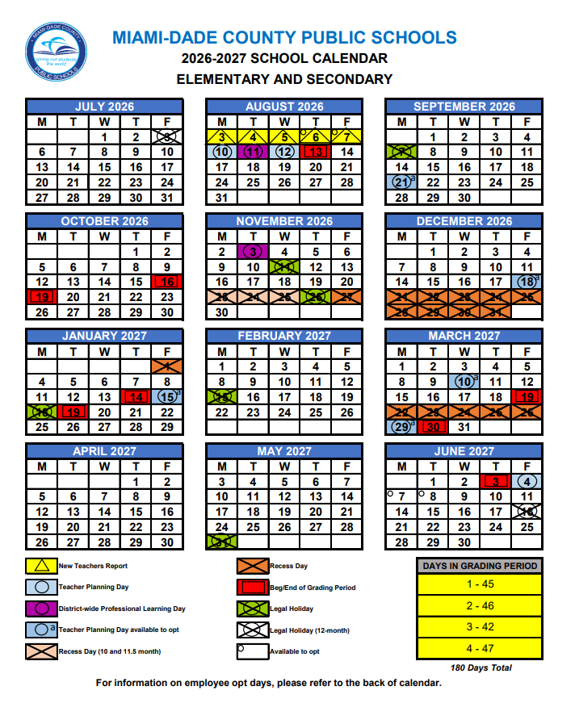
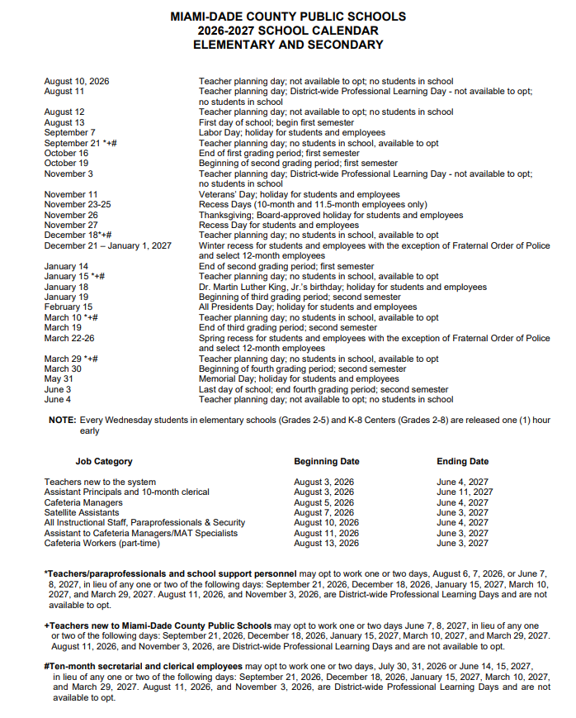

APPENDIX B – Florida Statues and School Board Policies
View all School Board Policies at: School Board Bylaws & Policies

Academics
- 2235 - MUSIC, ART, AND PHYSICAL EDUCATION
  - Music, art, and physical education are fundamental subjects in the school's curriculum because they contribute to every child’s academic and social development. Art and Music education helps level the "learning field" across socio-economic boundaries while strengthening student problem-solving and critical thinking skills and contributing to the overall academic achievement of students. Physical education provides students the opportunity to attain their optimal of fitness while participating in a carefully planned program of physical activities. Through participation, students develop interest and skills that promote and encourage lifetime fitness while stimulating brain functions that enhance academic achievement.

- 2240 - CONTROVERSIAL ISSUES AND STUDENT EXPRESSION
  - Students are encouraged to participate in discussions, speeches, and other expressions in which many points of view, including those that are controversial, are freely explored. A controversial issue is a topic on which opposing points of view have been promulgated by responsible opinion or likely to arouse both support and opposition in the community.

- 2370.01 – VIRTUAL INSTRUCTION
  - The enrollment period for the District-operated full-time virtual instruction program, Miami-Dade Online Academy, opens in the spring of each school year for a minimum of ninety days and closes thirty days before the first day of the school year.

• 2416 – STUDENT PRIVACY AND PARENTAL ACCESS TO INFORMATION
  - No student shall be required, as a part of the school program or the District's curriculum, without prior written consent of the student (if an adult, or an emancipated minor) or, if an unemancipated minor, his/her parents, to submit to or participate in any survey, analysis, or evaluation that reveals information.
  - Parents have the right to inspect, upon request, any instructional material used as part of the educational curriculum of the student and within a reasonable period of time after the request is received by the building principal. "Instructional material" means instructional content that is provided to a student, regardless of its format, including printed and representational materials, audio-visual materials, and materials in electronic or digital formats (such as materials accessible through the Internet). The term does not include academic tests or assessments.

- 2417 – REPRODUCTIVE HEALTH AND DISEASE EDUCATION
- The School Board shall provide comprehensive reproductive health and disease education to secondary students.
- Parents will be notified in advance when the reproductive health and disease lessons - will be taught in the classroom and encouraged to review the program content and instructional materials.
- Parents may request that a student be exempted from the teaching of reproductive health or any disease, including HIV/AIDS, its symptoms, development and treatment; and the process for requesting such exemption. An appropriate alternative educational assignment will be provided for any student who receives an exemption.

- 2421 - K-12 CAREER-TECHNICAL EDUCATION PROGRAM
  - Career-technical education is designed to provide career and technical education experiences. These experiences will complement and reinforce academic concepts that are particularly amenable to contextualized learning in a distinct career area and provide occupationally specific skills.

- 2432 – DRIVER EDUCATION
- The driver education program is designed for high school students who elect to participate in any of the available state approved driver education courses and that the purpose of the program is to introduce students to Florida driving laws/rules of the road and safe driving behavior.

- 2440 - SUMMER SCHOOL
  - The School Board may conduct a summer program of academic instruction for students in grades K-12 and Special Education (SPED) students needing extended school year services as identified in their Individual Education Plan (I.E.P.). The School Board may also choose to implement summer enhancement programs, contingent upon available funding. The School Board shall provide transportation for full-time SPED students and other students as appropriate.

- 2510 - INSTRUCTIONAL MATERIALS, SCHOOL LIBRARY/MEDIA CENTER, AND OTHER EDUCATIONAL MATERIALS
  - Meetings of committees convened for the purpose of ranking, eliminating, or selecting instructional materials for recommendation to the district school board must be noticed and open to the public and committees convened for such purposes must include parents of district students.
  - The District shall maintain on its website a current list of instructional materials, by grade level, purchased by the District. This list can be accesses at http://im.dadeschools.net/. Elementary schools shall maintain a list of materials available at the school on the school website. Parents may object to instructional materials in accordance with District procedures.

- 2623 - STUDENT ASSESSMENT
  - Student assessment shall comply with the law and State Board of Education rules to determine the progress of students and to assist them in attaining student performance objectives and the educational achievement goals of the District.
  - State-mandated tests (e.g., diagnostic assessments and achievement tests) shall be administered to all eligible students at the times designated by the State Board of Education.
  - Administrative procedures for test security and confidentiality of student results are in place to maintain the integrity of District and State assessments.

- 5410 - STUDENT PROGRESSION PLAN
  - Provides guidance to teachers, school and district administrators, parents and other stakeholders regarding the requirements and procedures for students to progress from one grade to the next, Kindergarten through grade 12 and Adult Education. The information presented in the document is derived from requirements set forth by Florida Statutes, State Board of Education Rules and policies established by The School Board of Miami-Dade County.

Accident Reports/Incident Reports/School Safety
- 1139 – EDUCATOR MISCONDUCT
  - Within 24 hours after notification to the Superintendent or governing board chair of a charter school by a law enforcement agency that an employee has been arrested for a felony or misdemeanor involving the abuse of a minor child or the sale or possession of a controlled substance, the school principal or designee shall notify parents of enrolled students who had direct contact with the employee and include, at a minimum, the name and specific charges against the employee.

- 3213 - STUDENT SUPERVISION AND WELFARE
  - Protecting the physical and emotional well-being of students is of paramount importance. Each instructional staff member shall maintain the highest professional, moral, and ethical standards in dealing with the supervision, control, and protection of students on or off school property.
  - Staff members shall report immediately to a building administrator any accident, safety hazard, or other potentially harmful condition or situation s/he detects.
  - Staff members shall provide proper instruction in safety matters.
  - Any parent with a concern regarding the implementation of the provisions of F.S. 1001.42(8)(c) may file a written complaint with the principal of their child's school.

- 5540 - INVESTIGATIONS INVOLVING STUDENTS
  - School administrators shall respond to incidents involving students occurring on school grounds or at school-sponsored events. When conducting an initial fact inquiry, if an administrator suspects that a crime has been committed, they must report the matter to School Police or another appropriate law enforcement agency to assume the investigative responsibilities.

- 5772 - WEAPONS
  - Students are prohibited from possessing, storing, making, or using a weapon, including a concealed weapon, in a school safety zone and any setting that is under the control and supervision of the School Board for the purpose of school activities approved and authorized by the School Board including, but not limited to, property leased, owned, or contracted for by the School Board, a school-sponsored event, or in a School Board-owned or private vehicle.

- 7217 - WEAPONS
  - Visitors are prohibited from possessing, storing, making, or using a weapon, including a concealed weapon, in a school safety zone and any setting that is under the control and supervision of the School Board for the purpose of school activities approved and authorized by the School Board including, but not limited to, property leased, owned, or contracted for by the School Board, a school-sponsored event, or in a School Board-owned or private vehicle.

- 8141 – MANDATORY REPORTING OF MISCONDUCT BY EMPLOYEES
  - III. Parental Notification of Alleged Misconduct
    - Within thirty (30) days of the date on which the District learns of misconduct by instructional personnel, educational support employees, and school administrators that affects the health, safety, or welfare of a student, including misconduct that involves engaging in or soliciting sexual, romantic, lewd conduct with a student, or any conduct that would result in disqualification from educator certification or employment as provided in F.S. 1012.315 the parent of a student who was subjected to or affected by such misconduct shall receive written notification informing the parent.

- 8405 - SCHOOL SAFETY
  - The School Board is committed to maintaining a safe and drug-free environment in all of the District’s schools. School crime and violence are multifaceted problems that need to be addressed in a manner that utilizes all available resources in the community through a coordinated effort of School District personnel, law enforcement agencies, and families. School administrators and local law enforcement officials must work together to provide for the safety and welfare of students while they are at school or a school-related event or are on their way to and from school. Parents have the right to access SESIR data and to receive timely notification of threats, unlawful acts, and significant emergencies, certain arrests of employees. Student identification cards issued by the District to students in grades 6 through 12 include the telephone numbers for national or statewide crisis and suicide hotlines and text lines. Emergency drills for active assailant and other emergencies shall be conducted at least once every nine (9) week reporting period.

- 8410 – EMERGENCY MANAGEMENT, PREPAREDNESS, AND RESPONSE
- The School Board recognizes that its responsibility for the safety of students and staff requires that it formulate and prescribe emergency management and emergency preparedness procedures for District schools, in consultations with appropriate public safety agencies, including emergency notification procedures for life-threatening emergencies, including, but not limited to, fires; natural disasters; bomb threats, weapon-use, hostage, and active assailant situations; hazardous materials or toxic chemical spills; weather emergencies, including hurricanes, tornadoes, and severe storms (see Policy 8420.01); and exposure as a result of a manmade emergency; and that such emergencies are best met by preparedness and planning.
- The District Critical Incident Response Team (DCIRT) is responsible for assisting schools with emergencies/critical incidents as needed and coordinate District resources.
- FLORIDA STATUTES, SECTION 943.082 – SCHOOL SAFETY AWARENESS
PROGRAM
- FortifyFL is a suspicious activity reporting tool that allows users to instantly relay information to appropriate law enforcement agencies and school officials. FortifyFL was created and funded by the 2018 Florida Legislature as part of the Marjory Stoneman Douglas High School Public Safety Act. It is available for free download from the Apple App Store and Google Play Store. It may also be accessed from the Dadeschools.net homepage, as well as the student, parent, and employee portal pages. A link to FortifyFl has also been placed on each school site information page.
- Florida Statute 943.082 states that if, following an investigation, it is determined that a person knowingly submitted a false tip through FortifyFL, the Internet protocol (IP) address of the device on which the tip was submitted will be provided to law enforcement agencies for further investigation, and the reporting party may be subject to criminal penalties under s. 837.05. In all other circumstances, unless the reporting party has chosen to disclose his or her identity, the report will remain anonymous.

Admission, Registration and Immunization Requirements
- 5112 - ENTRANCE REQUIREMENTS
  - Establishes the admission and registration requirements for students entering school. The following documents and forms are to be provided upon initial registration:
    - Original birth certificate
    - Verification of age and legal name
    - Proof of a physical examination by an approved health care provider including a tuberculosis health clinical screening, appropriate follow-up if required, and a Florida Certificate of Immunization, DH-680 Form
    - Verification of parent/legal guardian current residence (address)
  - Requires the registering parent to submit truthful and accurate information in accordance with current court orders related to parenting matters.
  - The school shall abide by information provided by the parent who completes the initial registration documents or “registering parent.” Any person verified as a parent in the District’s Student Information System is presumed to be authorized to pick up the student unless otherwise indicated. Parents have the right to change the registering parent by agreement. Any subsequent change to the registering parent listed in the District’s student information system must be verified by both parents in accordance with District procedures. Only the registering parent will be permitted to withdraw the student from the school. Any parent contesting the information on the initial registration forms may seek assistance from the court to compel the registering parent to revise the information on the forms. School staff shall provide such persons with the website for the Family Court Self-Help Program at http://www.jud11.flcourts.org/Family-Court-Self-Help-Program. Parents may agree to change the registering parent and submit an Agreement to Change of Registering Parent Form (FM-7600) at any time.

- 5114 - FOREIGN STUDENTS
  - Entry requirements into schools are the same for all students, regardless of country of birth and immigration status. All students will register at the school of the actual residence of the parent in the attendance area as approved by the School Board.

- 5320 – IMMUNIZATION
  - All students shall be immunized against polio, measles-mumps-rubella (MMR) diphtheria, pertussis tetanus (DTaP), hepatitis B, and varicella (chicken pox). Students with a documented history of the varicella (chicken pox) disease by a medical provider on the Florida Certificate of Immunization DH-680 Form are not required to receive the varicella vaccine. This policy applies to students who currently attend school in the District and those eligible to attend.
  - A student who has not completed the required immunization will not be admitted to school.
  - The Centers for Disease Control (CDC) also recommends students should receive an annual flu vaccine by the end of October, and all eligible students are encouraged to receive the COVID-19 vaccine including COVID-19 vaccine booster shots to help protect against the virus.

Animals on District Property
- 8390 - ANIMALS ON DISTRICT PROPERTY
  - Service animals as required by law are permitted in schools. “Service animals” pursuant to 28 C.F.R. 35.104, means any dog that is individually trained to do work or perform tasks for the benefit of an individual with a disability, including a physical, sensory, psychiatric, intellectual, or other mental disability.
  - All animals, including service animals, housed on District property or brought on District property on a regular basis must meet every State and County veterinary requirement, including but not limited to, rabies vaccination or other inoculations required to be properly licensed.
  - Students are not allowed to bring pets to school.

Anti-Discrimination Policy
- 5517 – PROHIBITION ON DISCRIMINATION AND HARASSMENT AGAINST STUDENTS BASED ON PROTECTED CATEGORIES
  - The Board will enforce its prohibition against discrimination and harassment based on age, citizenship status, color, disability, ethnic or national origin, Family Medical Leave Act (FMLA), gender, gender identity, genetic information, linguistic preference, marital status, political beliefs, pregnancy, race, religion, retaliation, sex, sexual harassment, sexual orientation, social/family background, and any other basis prohibited by law. The Board shall maintain an educational and work environment free from all forms of discrimination and harassment, including discrimination and harassment prohibited by Title IX of the Education Amendments of 1972.
  - This policy prohibits discrimination and harassment at locations, events, or circumstances over which the Board exercises substantial control over both the respondent and the context in which the prohibited conduct occurs, including but not limited to such events occurring on school property, during any school-related or school-sponsored program or activity, and on school-sponsored transportation. This policy also prohibits retaliation against a person who has made a report or filed a formal complaint alleging unlawful discrimination or harassment, or who has participated as a witness in a discrimination or harassment investigation.

- 5517.01 – Bullying and harassment
  - The School Board is committed to providing a safe learning environment for all students and shall strive to eradicate bullying and harassment in its schools by providing awareness, prevention, and education in promoting a school atmosphere in which bullying, harassment, and intimidation will not be tolerated by students, Board employees, visitors, or volunteers.
  - This policy is also incorporated by reference into the Code of Student Conduct, and supersedes any existing policy, guideline, or Board policy regarding bullying and harassment that may be inconsistent with this policy. These policies apply to all students in the District.
  - This policy does not replace the District’s current policy prohibiting harassment on the basis of age, citizenship status, color, disability, ethnic or national origin, Family Medical Leave Act (FMLA), gender, gender identity, genetic information, linguistic preference, marital status, political beliefs, pregnancy, race, religion, retaliation, sex, sexual harassment, sexual orientation, social/family background, and any other basis prohibited by law.

- 5517.02 - DISCRIMINATION/HARASSMENT COMPLAINT PROCEDURES FOR
STUDENTS
- This policy provides the steps for individual complaints of discrimination and harassment based on protected categories and the process for addressing the complaints.
- Students and parents are encouraged to promptly report complaints of discriminatory or harassing conduct to their principal. Additionally, they may report complaints of discriminatory or harassing conduct to the Region Office or the District’s Office of Civil Rights Compliance (CRC).
- All complaints involving student-on-student harassment will be first investigated at the school site. If such complaints are made directly to a District office, the Region Office, or the CRC Office, they will be referred to the school site for the initial investigation. For more information on discrimination and harassment based on the protected categories, please contact CRC at (305) 995-1580 or visit http://tinyurl.com/MDCPS-CRC.

Attendance Policy/School Hours
- 5200 – ATTENDANCE
  - Student attendance is a means of improving student performance and critical in raising student achievement. Together, the staff of Miami-Dade County Public Schools, students, parents and the community must make every effort to lessen the loss of instructional time to students.
  - Absences shall be reported to the school attendance office by the parent or adult student within three (3) schools days upon the return to school. The Superintendent shall require, from the parent of each student of compulsory school age or from an adult student who has been absent from school or from class for any reason, a statement of the cause for such absence. The District reserves the right to verify such statements and to investigate the cause of each single absence.
  - Educators shall encourage regular attendance of students, maintain accurate attendance records, and follow reporting procedures prescribed by the Superintendent.

- 5225 - ABSENCES FOR RELIGIOUS HOLIDAYS
  - Student absences for religious purposes, as identified on the approved holidays listed in the Student Attendance Reporting Procedures PK-12 Handbook, may not prohibit students from receiving attendance awards or other attendance incentives at the school level, region level, or District level.

- 5230 - LATE ARRIVAL AND EARLY DISMISSAL
  - Students shall be in attendance throughout the school day. If a student will be late to school or dismissed before the end of the school day, the parent shall notify the school in advance and state the reason for the tardiness or early dismissal. Justifiable reasons shall be determined by the principal. Students will be counted absent if they are not present in class for at least half of the class period. A student is in attendance for a full school day if the student is actually present for at least two (2) hours of the school day, is engaged in an approved, school-sponsored educational activity which constitutes a part of the instructional program for the student, or is participating in pre-approved extra-curricular activities.
  - The registering parent shall indicate on the Emergency Student Data Form the individual(s) to whom the student may be released during the school day.
  - The registering parent who completes the Emergency Student Data Form is responsible for providing information that is truthful and accurate – and in the case of unmarried, divorced, or separated parents, consistent with any court order in effect governing their divorce, separation, or parenting matters.

- 8220 - SCHOOL DAY
  - The Superintendent shall annually establish the hours of the school day. The Superintendent may authorize exceptions from the regular school day.
  - The Superintendent may close the schools, delay the opening of school, or dismiss school early when such alteration in the regular session is required for the protection of the health and safety of students and staff members.
Ceremonies & Observances
- 8800 - RELIGIOUS CEREMONIES/OBSERVANCES AND MOMENT OF QUIET REFLECTION
- Acknowledgement of, explanation of, and teaching about religious holidays of various religions is permitted. Celebration activities involving nonreligious decorations and use of secular works are permitted, but it is the responsibility of all faculty members to ensure that such activities are strictly voluntary, do not place an atmosphere of social compulsion or ostracism on minority groups or individuals, and do not interfere with the regular school program. The principal of each school shall require teachers in the first class period of the school day in all grades to set aside at least one (1) minute, but not more than two (2) minutes, daily, for moment of silence, during which time students may not interfere with other students’ participation. The amendments prohibit a teacher from making suggestions as to the nature of any reflection that a student may engage in during the moment of silence and require each teacher in the first class period of the day to encourage parents and guardians to discuss the moment of silence with their children and make suggestions as to how their children can best use this time.

Class Size
- CLASS SIZE STATE STATUTE
  - Florida citizens approved an amendment that set limits on the number of students in core academic classes in public schools. The amendment requires classes to be in compliance at the class level. However, pursuant to language passed by the 2013 Florida Legislature in HB 7009 and subsequently approved by the Governor, amending Florida Statute 1002.31, Public School Parental Choice, the calculation for compliance with class size limits pursuant to Florida Statute 1003.03 for a school or program that is a public school of choice is measured by the average number of students at the school level.

Clinic
- 5330 – STUDENT USE OF MEDICATIONS
  - The School Board shall not be responsible for the diagnosis and treatment of student illness. The administration of prescribed medication and/or medically prescribed treatments to a student during school hours will be permitted only when failure to do so would jeopardize the health of the student, the student would not be able to attend school if the medication or treatment were not made available during school hours, or the child is disabled and requires medication to benefit from his/her educational program. Prior to the administration of any prescribed medication by the school nurse or school staff, the student’s parent shall provide to the Principal written medication authorization signed by the child’s medical provider.

Code of Student Conduct
- 2455 - DROPOUT PREVENTION AND ACADEMIC INTERVENTION PROGRAMS
  - The Superintendent may provide dropout prevention and academic intervention programs for students who, in the opinion of the Superintendent, will benefit from such programs. Participation in a dropout prevention and academic intervention program does not exempt the student from complying with school attendance rules or the Code of Conduct.

- 5136.02 - SEXTING
  - Sexting is the act of sending or forwarding through cellular telephones and other electronic media sexually explicit, nude, or partially nude photographs/images. It is the District's mission to ensure the social, physical, psychological, and academic well-being of all students. The educational purposes of the schools are best accomplished in a climate of student behavior that is socially acceptable and conducive to the learning and teaching process.

- 5500 - STUDENT CONDUCT AND DISCIPLINE
  - Schools shall promote a positive school climate that supports academic achievement and emphasizes civility, fairness, mutual respect, and acceptance of diversity. The Code of Student Conduct Elementary, Code of Student Conduct Secondary, and the Post-Secondary Code of Student Conduct, incorporated by reference, apply to all students in the District. Copies of these documents are on file in the Office of Board Recording Secretary, and the Citizen Information Center, and shall be available in each school and special center.
  - The Superintendent, principals, and other administrators shall assign discipline/corrective strategies to students pursuant to the Code of Student Conduct and, where required by law, protect the student’s due process rights to notice, hearing, and appeal. Additional guidelines for the maintenance of appropriate student behavior are issued by memorandum from District administration.
  - The Superintendent shall make the Code of Student Conduct available to all students and their parents.

- 5511 - DRESS CODE AND SCHOOL UNIFORMS
  - Students are expected to come to school with proper attention having been given to personal cleanliness, grooming, and neatness of dress. Students whose personal attire or grooming distracts the attention of other students or teachers from their schoolwork shall be required to make the necessary alterations to such attire or grooming before entering the classroom or be sent home by the principal to be properly prepared for school. Students who fail to meet the minimum acceptable standards of cleanliness and neatness as determined by the principal and as specified in this policy shall be subject to appropriate disciplinary measures.

Equal Opportunity
- 2260 - NONDISCRIMINATION AND ACCESS TO EQUAL EDUCATIONAL
OPPORTUNITY
  - The School Board shall provide equal opportunity for all students and will not discriminate or tolerate harassment in its educational programs or activities on any basis prohibited by law or School Board Policy.

- 5111.01 - HOMELESS STUDENTS
  - The District Project UP-START program serves children and youth who are identified as meeting the Federal definition of "homeless". Homeless children and youth, including those who are not currently enrolled in school due to homelessness, shall have equal access to the same free appropriate public education (FAPE) in public schools and preschool education programs in the same manner as all other District students.
  - Additionally, homeless students shall have access to other services needed to ensure an opportunity to meet the same challenging State academic standards to which all students are held and to fully participate in the District’s academic and extra-curricular activities for which they meet relevant eligibility criteria. To that end, homeless students shall not be stigmatized or segregated on the basis of their status as homeless. The District shall establish safeguards that protect homeless students from discrimination on the basis of their homelessness and shall remove barriers identifying homeless children and youth.

Exceptional Student Education/Section 504
- 2260.01 SECTION 504 PROCEDURES FOR STUDENTS WITH DISABILITIES
- A student is entitled to a free appropriate public education FAPE and may be entitled to Section 504 accommodations if s/he has a physical or mental impairment that substantially limits one (1) or more major life activities.

- 2460 – EXCEPTIONAL STUDENT EDUCATION
- The School Board shall provide a free, appropriate, public education for students with disabilities according to State and Federal laws, rules, and regulations and shall implement the procedures document entitled Exceptional Student Education Policies and Procedures (SP &P).

- FLORIDA STATUTES, SECTION 1003.572 - PUBLIC-PRIVATE COLLABORATION
- Parents who wish to request public-private collaboration in the educational setting should direct requests to the principal for application of District procedures. Requests should be made in writing on District forms and specify the purpose of the collaboration. The principal will review requests and provide approval in accordance with statutory guidelines.

Fieldtrips/School Social Events
- 2340 - FIELD TRIPS
  - Field trips should supplement and enrich classroom procedures by providing learning experiences in an environment outside the schools, arouse new interests among students, help students relate school experiences to the reality of the world outside of school, bring the resources of the community - natural, artistic, industrial, commercial, governmental, educational - within the student's learning experience, and afford students the opportunity to study real things and real processes in their actual environment.
  - Field trips also include planned, student-travel activity approved as part of the District's total educational program and is under the direct supervision and control of an instructional staff member or any advisor designated by the Superintendent.

- 5850 - SCHOOL SOCIAL EVENTS
  - School facilities and appropriate staff will be made available for social events approved by the principal within and outside school facilities.

- 8640 - TRANSPORTATION FOR FIELD TRIPS
  - Regular or special-purpose school vehicles shall be used for transportation on field trips. These vehicles shall be owned or approved by the District and driven by approved drivers.

Financial Obligations
- 6152 - STUDENT FEES
  - The School Board may levy certain charges to students to facilitate the utilization of adequate, appropriate learning materials used in the course of instruction.

Food & Nutrition/Wellness Policy
- 8500 - FOOD SERVICES
  - The Food and Nutrition service program strives to provide school food services consistent with the nutritional needs of students and provide school food services that contribute to the student’s educational experiences and the development of desirable eating habits.

- 8510 - WELLNESS AND PHYSICAL EDUCATION POLICY
  - The District is committed to providing a healthy environment for students and staff within the school environment, recognizing that individuals must be physically, mentally, and socially healthy in order to promote wellness and academic performance.
  - The District focuses on achieving five goals: nutrition, physical education, physical activity: recess, health & nutrition literacy and preventive healthcare.
  - The District Wellness Policy provides guidelines for food sold on campus for fund raising activities.

- 8531 - STUDENT MEALS
  - Miami-Dade County Public Schools participates in the National School Lunch and Breakfast Program and offers healthy meals every day. For the 2026-2027 School Year, M-DCPS will implement a hybrid model combining CEP alongside traditional free and reduced meal applications.

Fundraising
- 5830 – STUDENT FUNDRAISING
  - Student fundraising by students is limited in order to prevent disruption and
includes student solicitation and collection of money for any purpose including collection of money in exchange for tickets, papers, or any other goods or services. Student fundraising in school, on school property, or at any school-sponsored event is permitted only when the profit is to be used for school purposes or for an activity connected with the schools.
  - No student, school organization, or member of the school staff may solicit funds in the name of the school from the public for any purpose without prior approval of the school principal and the Region Superintendent or his/her designee. All approvals must be in writing using the approved District forms and must be retained at the school for audit purposes.

- 6605 – CROWDFUNDING
  - Crowdfunding activities aimed at raising funds for a specific classroom or school activity, including extra-curricular activity, or to obtain supplemental resources (e.g., supplies or equipment) that are not required to provide a free appropriate public education to any students in the classroom may be permitted, but only with the specific approval by the principal and the region administrator. Crowdfunding for specific causes requires the approval of the Superintendent or his/her designee.

- 9211 – SCHOOL – ALLIED AND OTHER OUTSIDE SUPPORT ORGANIZATIONS
  - The School Board appreciates the efforts of all organizations whose objectives are to enhance the educational experiences of District students, to help meet educational needs of students and/or provide extra educational benefits.

Health Services
- 2410 - SCHOOL HEALTH SERVICES PROGRAM
  - The health services provided by the District shall supplement, not replace, parental responsibility, and shall appraise, protect, and promote student health. These services shall be designed to encourage parents to devote attention to their child’s health, identify health problems, and to encourage the use of the services of physicians, dentists, and community health agencies as needed.
  - Vision, hearing, scoliosis, and growth and development (Body Mass Index) screenings are conducted based on mandated grade levels. Screenings do not substitute a thorough examination in a medical providers office. Parents/guardians must provide the school with written notification if you do not want your child to participate in the screening program.

- 2410.01 MENTAL HEALTH SERVICES
  - In accordance with F.S. 1006.041, the School Board will implement a school-based mental health assistance program that includes training classroom teachers and other school staff in detecting and responding to mental health issues and connecting children, youth, and families who may experience behavioral issues with appropriate services.

Homework
- 2330 - HOMEWORK
  - Homework is an essential component of the learning process for students with the assignment of meaningful learning activities. While homework should provide opportunities for students to reinforce what is taught in the classroom, the assignments should be based on learning outcomes that build students’ conceptual understanding, develop thinking skills, and focus on the application of knowledge. Homework assignments should engage students in purposeful, relevant learning that meets their academic needs, with assignments emphasizing quality and depth over length and repetition. Homework is not to be assigned as punishment.
Interscholastic Athletics
- 2431 - INTERSCHOLASTIC ATHLETICS
  - A student participates in an interscholastic athletic activity and transfers to another school during the school year may continue to participate in the same interscholastic athletic activity at the prior school for the remainder of the school year if the parents of the student participating in the activity provide for the transportation of the student to and from the prior school at which the student participates in the activity. The student must continue to fulfill all eligibility requirements and meet the same standards of acceptance, behavior, and performance which is required of other students participating.
  - A student may not participate in an interscholastic athletic activity if the student participated in that same activity at another school during the school year, unless the student meets specific criteria as outlined in Board Policy 2431.

Internship
- 2424 - STUDENT INTERNSHIPS
  - Student participation in an internship program authorized by the High School to Business Career Enhancement Act may serve as a positive educational experience and provide a foundation for future employment opportunities.

Parent/School Choice/Magnet Schools
- 2370 - MAGNET PROGRAMS/SCHOOLS
  - Magnet programs/schools expand school choice, address declining enrollment, reduce overcrowding, comply with Federal and State mandates, meet parent/student interests, enhance education quality, and foster diverse student enrollments. These unique educational programs operate within the District, with extra resources and services offered to students beyond a single attendance boundary area.

- 5120 - STUDENT SCHOOL ASSIGNMENT AND ATTENDANCE BOUNDARY
COMMITTEE
- The assignment of students to District schools shall be consistent with the best interests of students and the best use of District resources.

- 5131 – SCHOOL CHOICE AND CONTROLLED OPEN ENROLLMENT
  - This policy governs all District school choice placements , except for -placements in Magnet programs/schools that are subject to specific admissions requirements and governed by School Board Policy 2370, Magnet Choice Schools/Programs.
  - Controlled Open Enrollment allows the School District to make K-12 school assignments using parent’s indicated preferential educational choice as a significant factor. This section of the policy does not apply to charter schools. Charter schools must adopt their own controlled open enrollment policies and plans.
  - The Controlled Open Enrollment process will only be available following the annual magnet application window and will remain open for not less than four (4) weeks. All controlled open enrollment placements are subject to an approval process.
  - F.S 1003.3101 this section states that each school district board shall establish a transfer process for a parent to request his or her child be transferred to another classroom teacher. Parents cannot choose a specific classroom teacher for their child. Parents may request for his or her child to be transferred to another classroom teacher by contacting the school’s administration who will respond to the request within two weeks. Parents will be provided with reasons for any requests which are denied.

Parent Involvement
- 2111 - PARENT INVOLVEMENT– A HOME-SCHOOL-DISTRICT PARTNERSHIP
  - A collaborative environment is encouraged in which the parents and families of District students are invited and encouraged to be involved stakeholders in the school community. This policy establishes the framework and responsibilities for implementation of strategies to increase family and community involvement. A copy of this policy must be distributed to all parents.

- 5780 – PARENTS’ BILL OF RIGHTS
  - The Parents’ Bill of Rights contains information about School Board policies to support strong, continuing family and community involvement in all aspects of school programs and activities provides support for measurable improvement in student achievement. See also https://parentsbillofrights.dadeschools.net/.

- 9210 - PARENT ORGANIZATIONS
  - The Parent-Teacher/Parent-Teacher-Student Associations (PTA/PTSA) in the District are acknowledged as sincerely interested in, and staunch supporters of public education in Miami-Dade County.

Pledge of Allegiance
- 8810 - THE AMERICAN FLAG AND OFFICIAL MOTTO OF THE STATE OF FLORIDA
  - The Pledge of Allegiance shall be recited at the beginning of the day in every school.
  - A student has the right not to participate in reciting the pledge. Upon written request by his/her parent, the student must be excused from reciting the pledge, including standing and placing the right hand over his/her heart.

Privacy
- 2416 - STUDENT PRIVACY AND PARENTAL ACCESS TO INFORMATION
  - Parents have the right to inspect, upon request, a survey or evaluation created by a third party, or any instrument used in the collection of personal information before the survey/evaluation is administered or distributed by the school to the student. The parent will have access to the survey/evaluation or instrument within a reasonable period of time after the request is received by the principal.

School Transportation/Bus Safety Conduct
- 8600 – TRANSPORTATION
  - Students living more than two miles from their home school will be eligible for District-provided bus transportation. Students who attend school out of their home school zone will not be eligible for District-provided transportation.

Student Activities
- 5845 - STUDENT ACTIVITIES
  - All clubs and organizations approved by the principal to operate within the school must comply with this district policy. A student who wishes to represent the school through interscholastic competitions or performance must comply with the criteria set forth in policy.

Student Records/Access to Student Records
- 8330 - STUDENT INFORMATION, RECORDS, AND PRIVACY RIGHTS
- In order to provide appropriate educational services and programming, the School Board has the authority to create student educational records and is responsible for maintaining, reviewing for accuracy, and restricting access to the records. Continued efforts will be made to protect the accuracy and privacy of the information contained in student educational records.
- Parents and eligible students have the right to access education records, including the right to inspect and review those records, and have the right to waive their access to their education records in certain circumstances. Prior written consent of the parent, guardian, or eligible student shall be obtained prior to disclosing personally identifiable student information, except under certain circumstances.

- 8350 - CONFIDENTIALITY
  - A student's educational record and all personally identifiable information shall not be properly released except on the condition that the information being transferred will not be subsequently released to any other party without first obtaining the consent of the parent or adult/eligible student.

Student Services
- 2290 - CHARACTER EDUCATION
  - The School Board shall assist all students in developing the core values and strength of character needed for them to become caring, responsible citizens at home, school, and in the community. There are nine core values that form the basis for the character education program. These values are Citizenship, Cooperation, Fairness, Honesty, Kindness, Integrity, Pursuit of Excellence, Respect, and Responsibility.

- 5530 - DRUG PREVENTION
  - Schools shall strive to prevent drug abuse and help drug abusers through educational means.
  - The use, possession, concealment, or distribution of any drug or any drug-related paraphernalia, or the misuse of a product containing a substance that can provide an intoxicating or mood-altering effect or the misuse of any "over-the-counter" medications or substances are prohibited on school grounds, on school vehicles, and at any school-sponsored event.

Title I – Schoolwide Program
- 2261 - TITLE I SERVICES
  - The School Board elects to augment the educational program of disadvantaged students through the use of Federal funds, in accordance with the Elementary and Secondary Education Act (ESEA) of 1965, as reauthorized under the Every Student Succeeds Act of 2015. The ESEA is based on four (4) basic principles: stronger accountability for results, increased flexibility and local control, expanded options for parents, and an emphasis on proven educational methods. Parents of participating students are encouraged to be involved in programs, activities, and procedures that are planned and implemented to support children's academic growth.

Technology
- 7540 – COMPUTER TECHNOLOGY AND NETWORKS
  - The School Board is committed to the effective use of technology to both enhance the quality of student learning and the efficiency of Board operations. The School Board limits access and use of social media by students and staff members from the District's network, except for educational purposes.

- 7540.01 – SECURITY OF DISTRICT TECHNOLOGY
  - All District technology, as defined in Policy 7540, is considered District property and is to be used primarily for business or educational purposes. The District retains the right to access and review all District technology, including the District network, at any time. Users should have no expectation that any information on these systems is confidential or private.

- 7540.03 - STUDENT RESPONSIBLE USE OF TECHNOLOGY, SOCIAL MEDIA, AND
DISTRICT NETWORK SYSTEMS, & INTERNET SAFETY
  - The School Board provides students access to a large variety of technology and network resources which provide multiple opportunities to enhance learning and improve communication within the school district and the community. All users must, however, exercise appropriate and responsible use of school and District technology and information systems. Users include anyone authorized by administration to use the network. This policy is intended to promote the most effective, safe, productive, and instructionally sound uses of network information and communication tools.

- 7540.06 – STUDENT ELECTRONIC MAIL
  - This policy establishes the use of the District student electronic mail (e-mail) system and applies to any and all electronic messages composed, sent or received by anyone using the District’s student e-mail system. Authorized users of the student e-mail system are students, their parents and any other individuals or groups issued District student e-mail accounts

Threat Management
- FLORIDA STATUTES, SECTION 1006.07(7)
  - The Marjory Stoneman Douglas Act, among other things, requires the school district to form Threat Management Teams at each school to coordinate resources and assessment and intervention with individuals whose behavior may pose a threat to the safety of school staff and students.

Visitors
- 9150 - SCHOOL VISITORS
  - Parents, other adult residents of the community, and interested educators are encouraged to visit schools. All visitors must present identification that will be processed through the District’s RAPTOR system prior to being permitted entry into the school grounds.
  - The principal has the authority, however, to prohibit the entry of any person to a school or expel any person when there is reason to believe the presence of such person would be detrimental. If an individual refuses to leave the school grounds or creates a disturbance, the principal is authorized to request assistance from School Police or the local law enforcement agency to remove the individual. A visitor’s refusal to adhere to the school principal’s directive to leave the school grounds, will subject the visitor to arrest.
Volunteer Program
- 2430.01 - SCHOOL VOLUNTEERS
  - The School Board recognizes that certain programs and activities can be enhanced through the use of volunteers who have knowledge or skills that will be helpful to members of the school staff who are responsible for the conduct of those programs and activities. A school volunteer is any non-compensated person who may be appointed by the Superintendent or his/her designee. School volunteers may include, but are not limited to, parents, senior citizens, students, and others who assist the teacher or other members of the school staff.

APPEDIX C – Parents’ Bill of Rights
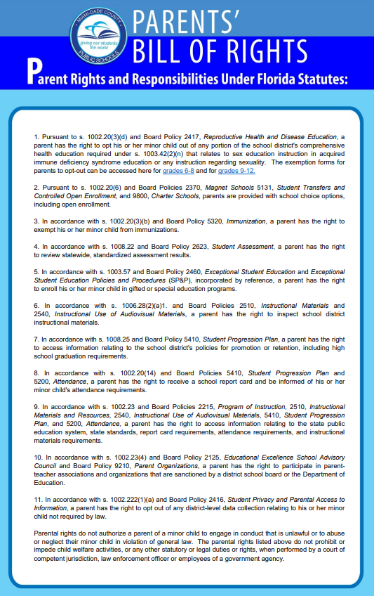

APPENDIX D – FortifyFL

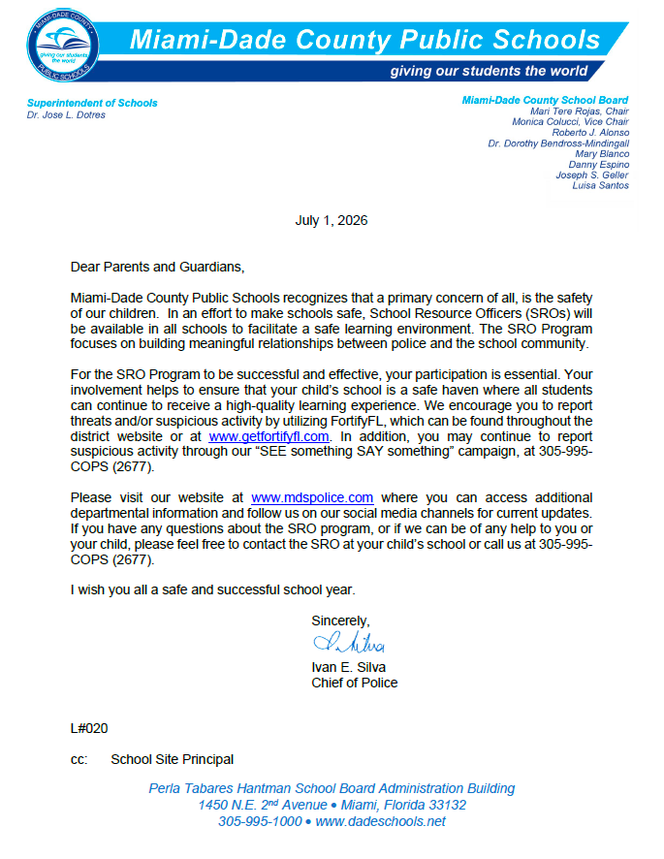
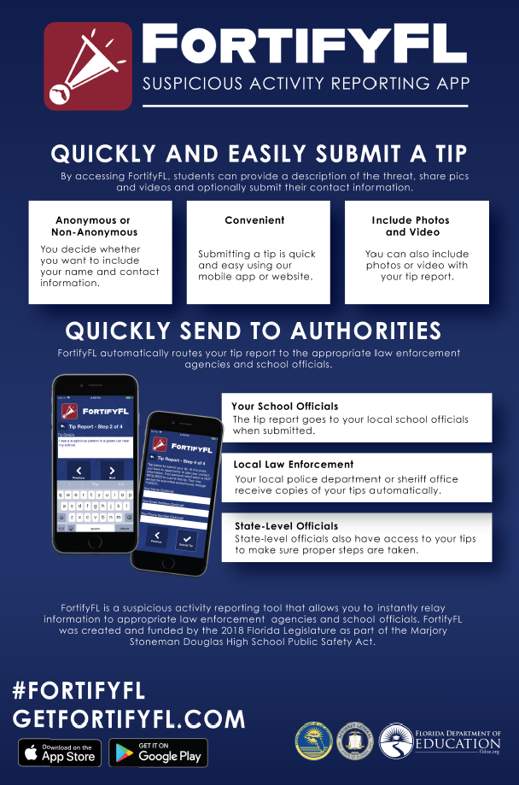

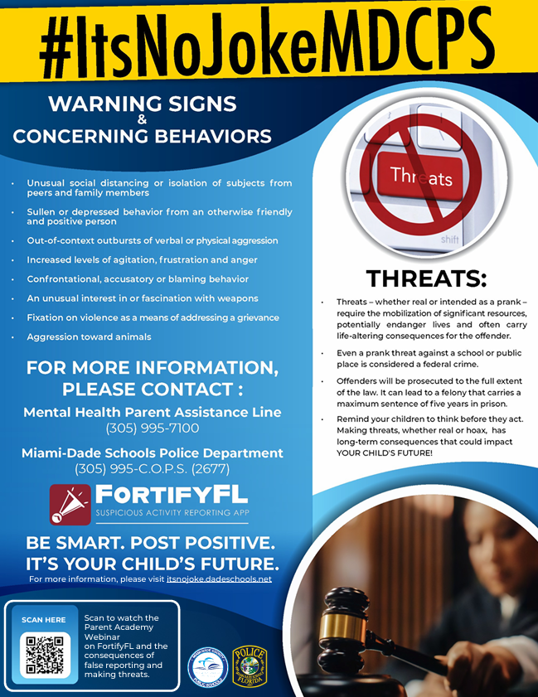
APPENDIX E – Discrimination/Harassment Poster and Policy
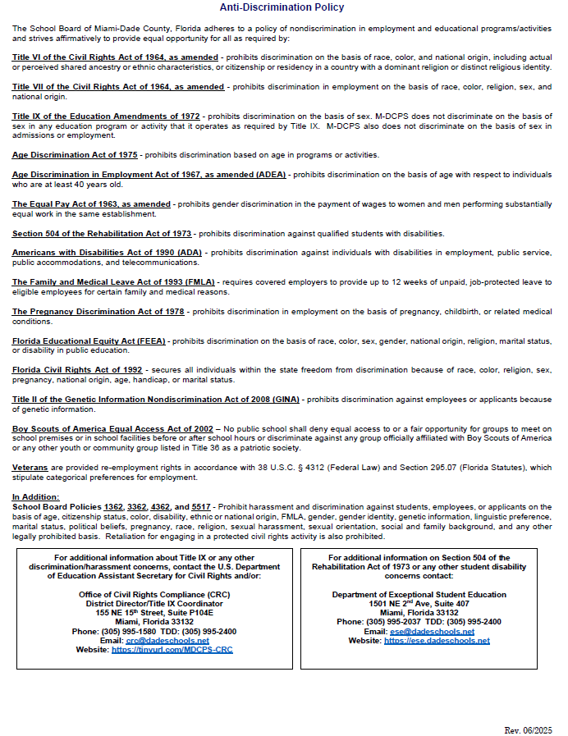

APPENDIX F – Standard Response Protocol
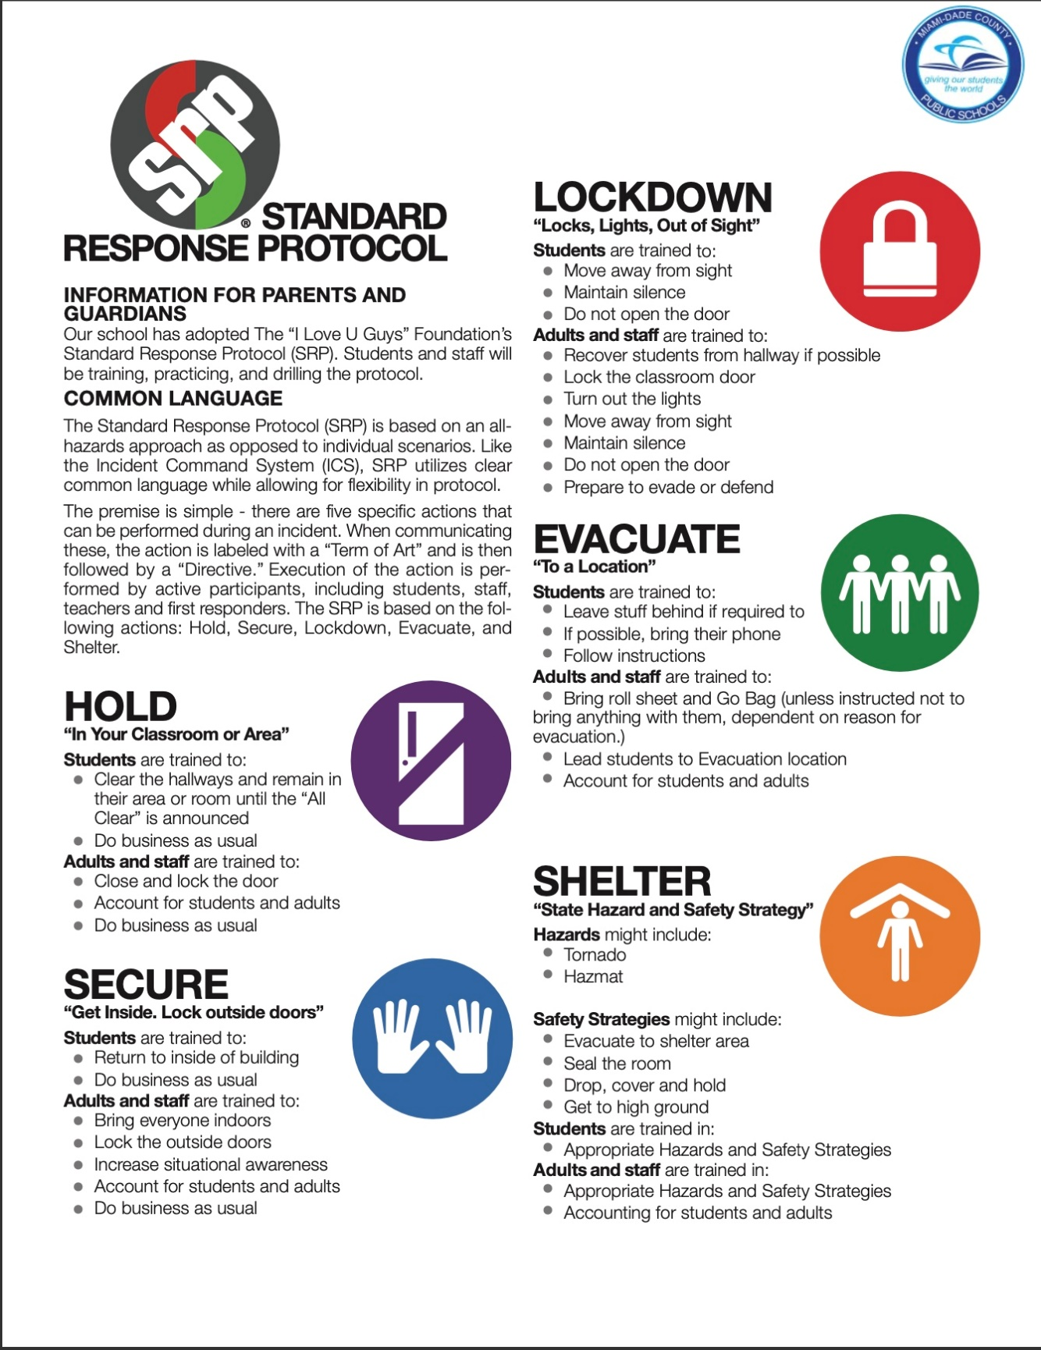

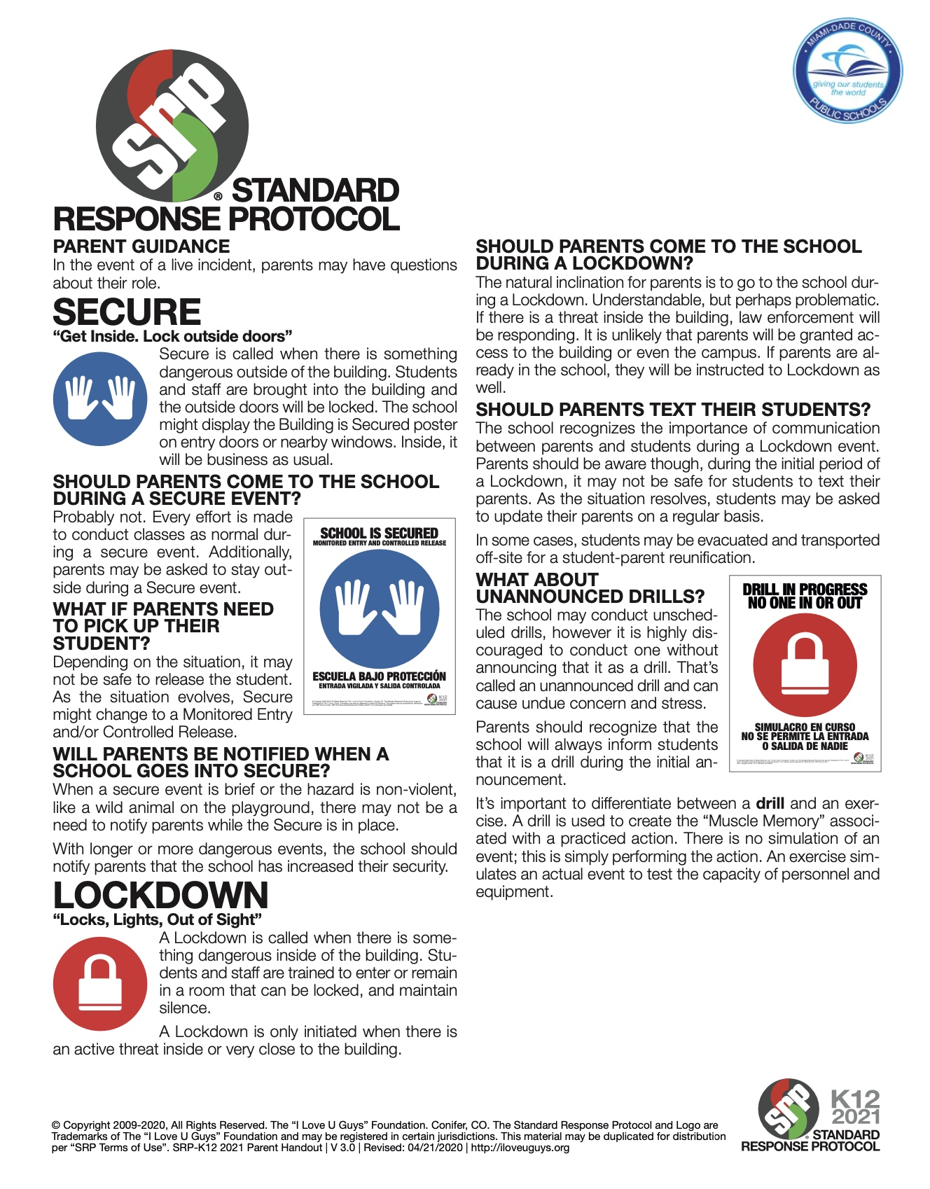

APPENDIX G – Dadeschools Mobile App
